Mad Cows 2010-2011
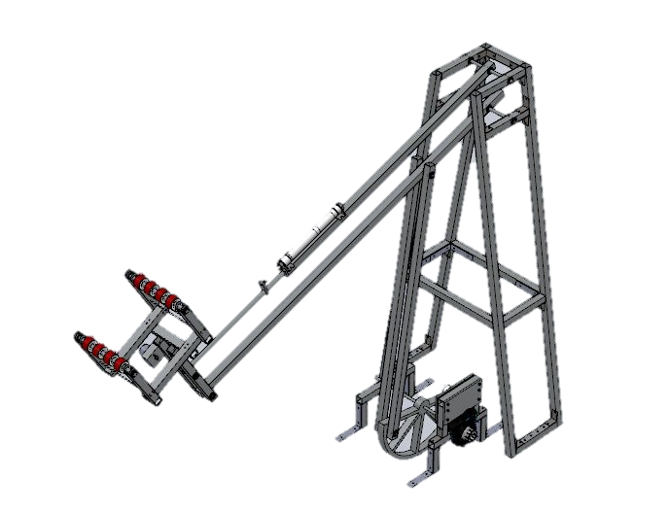
Off Season Project: Reverse Engineer Team 148’s Manipulator System
Written and compiled by: Carolyn Mason, Alizeh Rehman, and Gunnar Schmitt
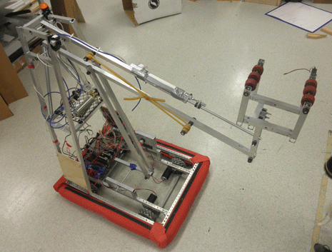
A special thanks to Team 148 for their help and feed back as well as feedback from other teams who posted on Chief Delphi!

- What We Saw
  - Competition 2010-2011 (Logomotion)
    - Our robot (Bessy):
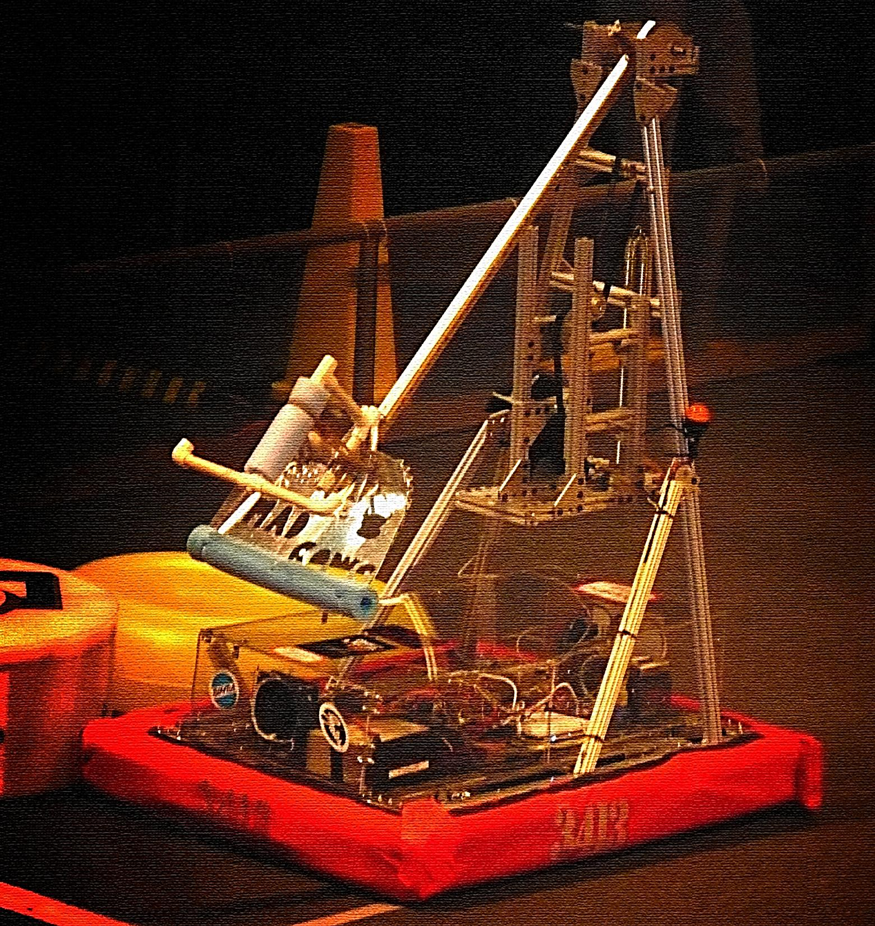
    - Bessy was designed 95% out of 80/20 and was very heavy. She weighed in at about 110 pounds without the mini-bot. The mini-bot deployment system was never attached because of weight issues and lack of time.
    - Plexiglas. Shattered and was very expensive.
    - The arm was subject to torsion and was weak. It was a single bar linkage attached to the top rotating shaft by shaft collars (which we drilled into to bolt into the arm bar).
    - The Manipulator did not have very good control over the game piece. Some teams had claws that could open and close, where ours relied on holding the tube with force.
    - We scored one point the entire game.
    - No sensors were used and we did not have an autonomous round.
    - At competition, we saw a few successful teams with well-designed robots. After looking into them we decided to build a simplified version of the Raptor (team 148’s robot).
- What We Did
  - Offseason Summer-Fall 2011
    - Goal: to build better drives, arms/lifts, manipulators, and chassis constructions.
    - We found photos and models of the Raptor robot and began to reverse-engineer it. We decided to use SolidWorks to design robots before physically building them. After a preliminary model was made, we reviewed, revised, and expanded the model until the mechanical portion was complete. Used SolidWorks 3-D central
    - After the model was complete, we made a full parts list with all the lengths of aluminum bars, aluminum rods, bolts, rivets, ball bearings, and shaft collars. Then we placed the order for the materials.
    - Basic Process:
      - Pick a robot subsystem
      - Sketch, compute math
      - Design in SolidWorks
      - Check, and check again
      - Create parts and assemblies document
- What Happened
  - SolidWorks:
    - Used the online SolidWorks Cad library to download parts. Some things we used were bolts, ball bearings, and pneumatic cylinders.
    - The McMaster-Carr website/ online catalog also provided models of some items, like ball bearings and shaft-collars.
    - In the final SolidWorks inspection, we missed that some of the ball bearings were actually too small for the rods. Because of this, we ordered the wrong parts and were set back a week.
    - Certain parts of the robot were left out of the SolidWorks model; the drivetrain, the electrical components (other than the Fisher price motor-gearbox and the Banebots motor for the claw), and the pneumatic mounting system.
    - After the SolidWorks model was completed, we assembled a black binder that contained the drawings of all the parts requiring holes to be drilled, major assemblies with parts labeled, a parts list for each of the major assemblies and images of the assembled model. This method worked well. We were able to have ten people work on the robot at once, because they all knew what the final product was supposed to look like.
  - Build:
    - Cutting the pieces took the longest amount of time. We had several setbacks.
    - We had difficulty finding a 7/8 drill bit and ended up buying one that was meant for heavy metal- and the drill bit had a circular shaft and kept stopping in the press. The drill bit we found was $15, we could have spent a lot more.
    - Many of the pieces were cut slightly off even if they were originally precisely measured. This caused problems in the final build. The pieces didn’t all fit together right, and were a little un-sturdy.
    - The rivets worked great! But only worked well when they were flush- which we found difficult to do in some cases. The rivets were much faster, easier, and end up being much lighter than bolting. We used a hand rivet gun, which was very tiring. For build season we are buying a rivet gun- hand drill attachment piece for $60.
    - Everything that was not built in SolidWorks took longer to figure out. For an offseason project- this was okay, because didn’t have the background to know how some of the pieces would work together. We learned that SolidWorks is an invaluable tool- if you know what you are doing with it. One suggestion is never build anything is you do not know how it works. We made several detailed hand drawings and did a lot of research- for build season, this is where prototyping is extremely important.
    - The motor mount block for the intended motor for the claw was going to be too expensive for us to make. When making the model we did not know that drill bits, especially large ones can get so expensive. We decided on a new mounting method. The new attachment method was not put into SolidWorks model.
    - We used two springs and latex tubing for the arm counterbalance. There is no need to put extra strain on the motor. With the counterbalance, the arm can lift faster as well.
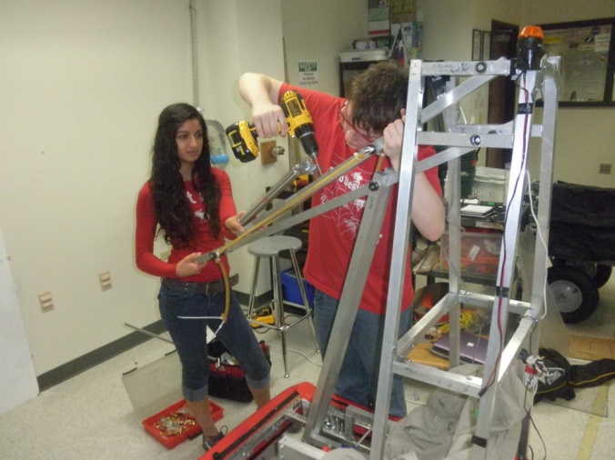
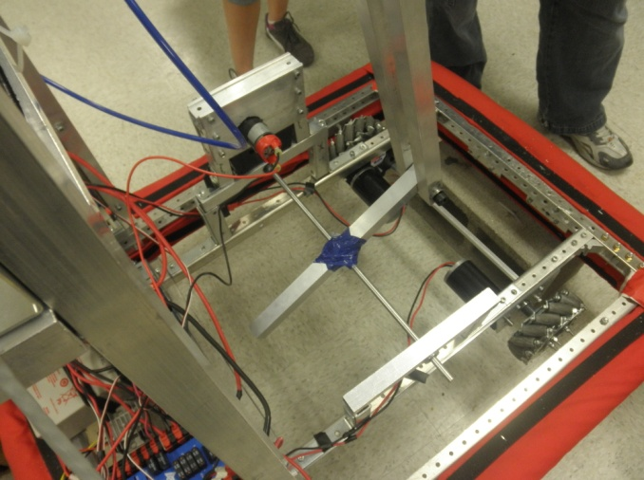
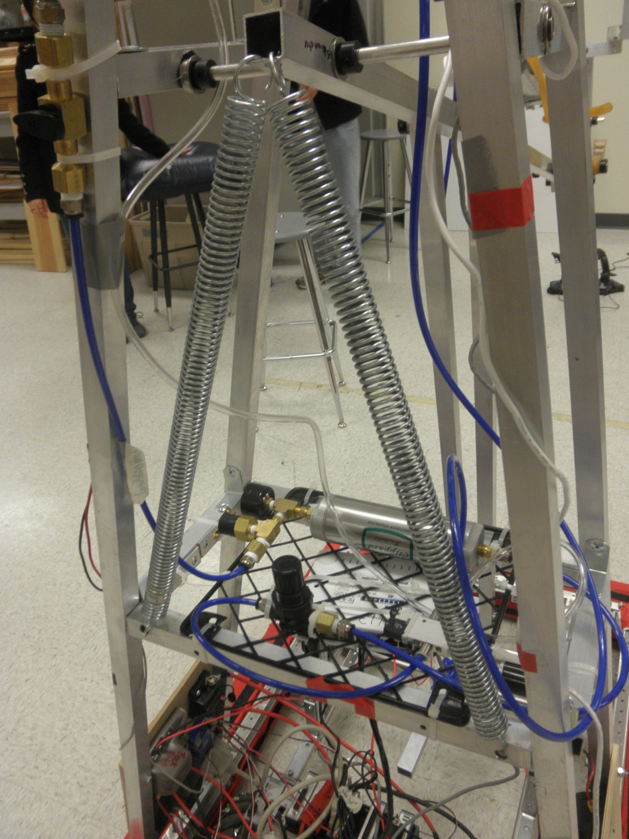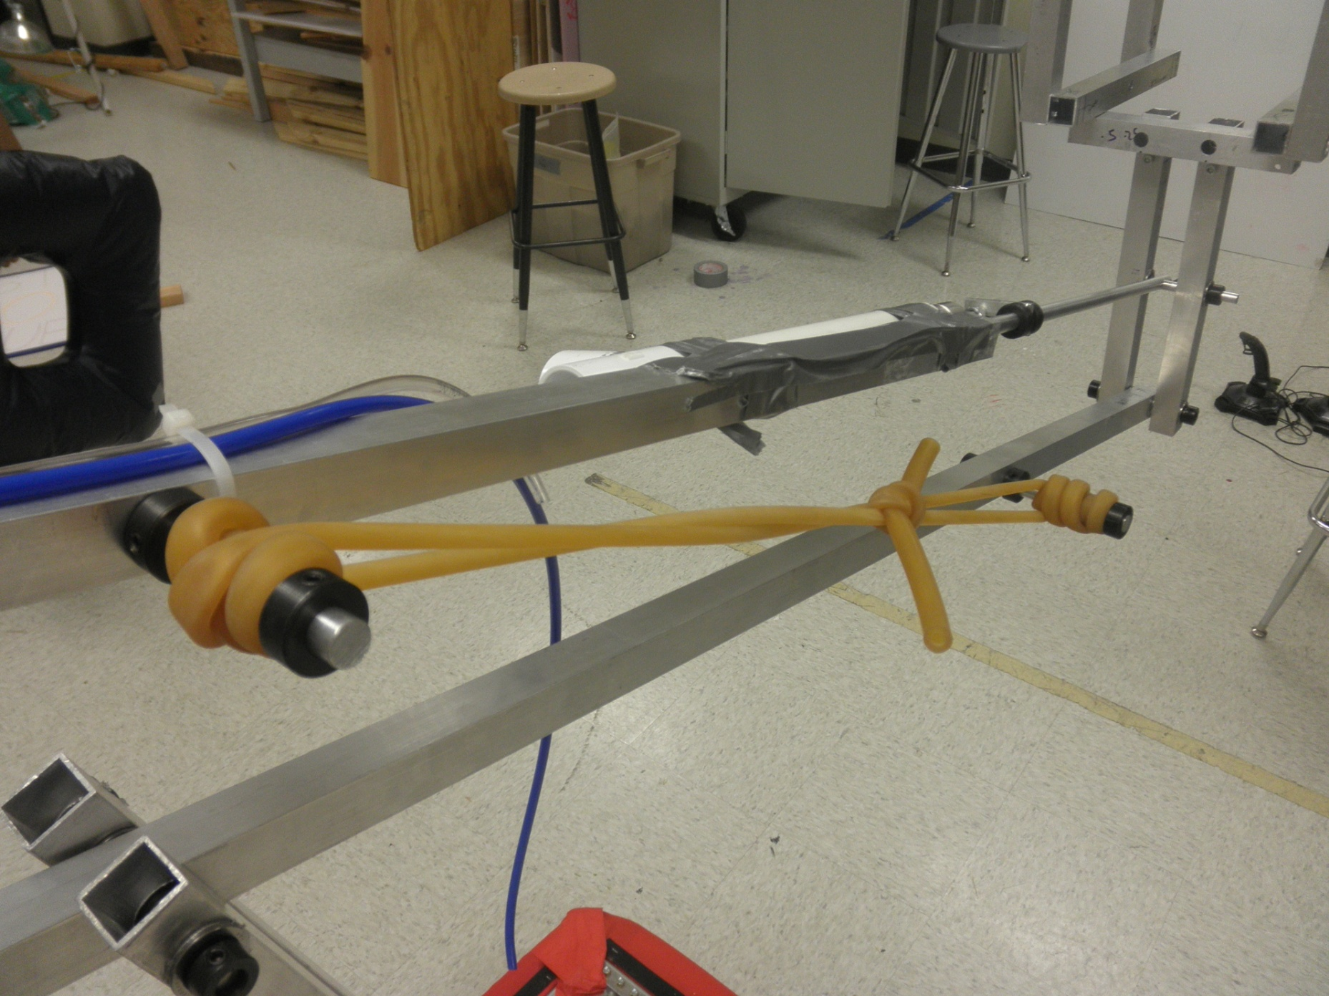
  - Design Feed Back from Chief Delphi:
    - Take off mechanum wheels. Mechanums add a lot of unnecessary weight. Depending on the game, they may or may not be needed.
    - Move the supporting mounts for the rod closer in at the bottom. (The rod had been bending in)
    - Work on pneumatics set-up—right now it may all bend and die.
    - Possible use a Y-bracket at the bottom to protect the claw when it is in its down position.
    - Work on weight distribution. However, this is all game dependant. For Logomotion is was okay.
- What Now?
  - Learn how to machine shop parts.
We think that machine shopping parts will help make our robot stronger and give us more build options. With Aluminum frame, we are a little bit constrained to box like shapes which can be clunky and not all that strong.
    - Metal used/ proposed thickness:
      - Team 971
        - Uses 0.090” 5052 H32 for 95% of the robot
        - However different thicknesses are used for different parts. Drive train may need to be thicker. Team 971 used 0.25” in 2006 and evolved their design when they got more confident. Last year they switched to 0.125” aluminum because they could save 27% on weight of chassis.
        - Thinner material saves time and money.
        - Weight can be saved by designing the right folds, joggles, rivet holes etc. while the robot still remains strong and stiff.
        - They are thinking of using 0.060in thick 5052 aluminum alloy this year.
      - Team 148
        - Uses sheet metal for their robot.
        - Uses 0.125” for chassis and other main frame pieces, 0.090” for secondary frame pieces and arms, 0.063” for end-effectors and anything that experiences minimal load or contact.
        - Uses flanges and support bracing in the right places.
      - Team 2643
        - Uses ballistic grade of Aluminum, i.e. 5083 that is work hardened.
  - Continue working on SolidWorks
    - Need to be faster for build season.
    - Learn how to run stress analysis, etc.
    - Learn how to use CAM
  - Work on a new setup for Electronics parts.
  - Greenville trip 12/17/11 to ask team 148 about their robot and how to improve design. (with Carolyn Mason, Drew Stonecipher, Jack Kisor, Matthew Johnston, and Gunnar Schmidt):
- For machine shopping:
  - What is the difference between machine shopping and sheet metal?
    - Machined parts are considered those that are made with drilling, milling, and lathe operations, whether they're manual or CNC based. We do a very small amount of machining - mostly lathed axles and things like that. Roughly 80-90% of our robot is made of sheet metal, however.
  - Is making a paper model beneficial?
    - Yes, but making something straight in SolidWorks is just as good. You can prototype with anything. Foam works well.
  - Any suggestions for cutting holes? Use triangles? Where?
    - Cut away as much as you can without making the pieces weak. When cutting holes make sure to leave ample space to the sides and even more around where ball bearings are place. They normally cut out triangles just because there is cross bracing within the piece.
  - Any alignment problems when parts come back?
    - No, not really as long as everything is planned right. Spend MORE time planning if you need to. Prototype out of wood, foam, anything really. Team 148 spent 3 weeks planning for the claw.
  - Thickness and type of metal?
    - Does this somewhat depend on skill? Should we start thicker like other teams?
      - Experience can let you go thinner, but basically using the right braces and supports can go a long way.
    - I know, the rotating piece at the bottom, you guys put several pieces of metal together, instead of cutting out of a really thick piece.. Reasons for that?
      - This was much cheaper. Team 148’s machine shop could only cut 1/8 metal anyway.
  - Help with CAM!
    - Everyone does it differently. Get in contact with your machine shop. They may just ask for the SolidWorks file.
  - How much of our robot do you suggest should be machined?
    - It doesn’t matter. Any robot can be built successfully, as long as it is done right. If you have access to a machine shop, then go for it! Team 148 machines most of their robot… however the main frame support is actually made out of 1” square aluminum bars. These bars are braced and supported by custom parts.
  - Do you run stress analysis on the robot before making the pieces?
    - Sometimes. They normally don’t mess with the stress tests. They know most of it by experience.
- Design help:
  - What motor did you use to lift your arm? How was it mounted?
    - Used a Bane bots 770 -geared up to go fast…. Wow. They said that the biggest misconception with FIRST is that you need to use a big motor for lift, but really with the right counterbalance, you don’t need that.
  - What is the most effective way to relieve an arm of torque.
    - Where to place springs? Use a counterweight/ pulley system? Use stretchy tubing?
      - They just used 11 rungs of surgical tubing that reached from the top of the 4-bar linkage to the bottom half. The compression made the arm perfectly balanced. The surgical tubing had zip ties around each end for easy removal.
  - What are the main design factors you look for?
    - We were thinking (in order of importance): Reliability, Durability, Strength, Simplicity, Weight, and speed.
      - Yes. They are all very important. When picking teams team 148 looks for teams that drive well and can score consistently. It doesn’t matter if the team is a big scorer if they don’t score well every time. Drive practice is also a big part of performance. Some of the best practice can be from the Thursday before game. Many teams are not able to practice and team 148 uses all the slots to play, tweak, and practice driving.
  - Do you use belts? How do you keep them from skipping?
    - Team 148 didn’t use any belts on the robot… besides the cord that was in the claw itself. As long as you keep them tight, then the belts should be fine. However, it is probably not a good idea to use long bits of chain. Why make a design harder than it needs to be? It is just added weight.
  - Do you use pneumatics in the manipulator?
    - YES. The manipulator had a jaw (powered by pneumatics) and a Bane bots motor that powered the pulley wheels. The pulley wheels were moved via a Polycord (a cord that you cut and heat to stick together) that runs over pulley wheels. On the back cords/ pulleys integrated both the wheels on the top and bottom of the jaw. One motor was basically able to power the pulley wheels on the top and bottom of the claw.
  - How do you feel about mecanum wheels?
    - Team 148 personally does not like them. They have seen many 6 wheel or 4 wheel tank drives make it to Einstein. The important thing is designing a reliable and consistent drive. Also, mecanums are heavy and very expensive. Is it worth losing the pushing power for greater maneuverability? Is it worth losing that speed? They tested them and were running at avery high amperage- a little crazy for just the drive.
  - Is making an all new drive train a bad idea for build season?
    - From personal experience, it is not a very good idea. Even if you develop the drive, it may not work. There will be kinks to be taken care of.. The most important thing about drive train is consistency.
  - How do you feel about rivets?
    - YES. Light weight. Easy to use. Keep metal together very well. They use Hydraulic rivet guns like-> http://www.harborfreight.com/3-16-inch-air-hydraulic-riveter-93458.html. Shop air is used to fill them up.
  - Help with weight distribution?
    - This depends very much on the game. For hills or bumps the Raptor would not have worked all that well. For the flat surface it worked beautifully.
  - Other random awesome design specs:
    - Team 148 created an Octocanum drive for the robot. The previous design had a 9th wheel in the center (Nonadrive), so that the robot could drive left and right without needing to turn. However, Logomotion did not call for that kind of versatility that Breakaway did, so they took it off. The robot had less maneuverability, but they saved about 12 pounds. That extra weight allowed them to beef up supports elsewhere. A good tradeoff.
    - Mini bot deployment was awesome- and overall very light weight. It was positioned on the back of the robot.
    - To keep a ball bearing in place, they fit it snugly into a hole and then drilled two small holes to either side. They use a rivet/ washer to hold the flanges of the ball bearing in place. Worked wonderfully.
    - Team 148 always uses keyed shafts and keyed pulleys/ sprockets when putting shaft systems together. They have a broach, where they just punch a square section out.
- Electrical Questions
  - How do you reinforce the auxiliary (the arm) in a way that the pneumatics systems will be most effective? (right now our arm isn’t strong enough to take the power of the pneumatics system)
    - Braces on the pneumatics system to mount it, lots of rivets on sheet metal, lots of sheet metal (They have it cut right next door), surgical tubing.
  - How exactly can the sensors be used? In the previous years, we haven’t used any sensors other than the camera (which we did not incorporate into anything...it was just there). We aren’t sure what is the best way to hook it up, the Sensors Manual has a couple different ways. Where should the sensors be placed? How might they be reinforced?
    - A potentiometer is used in the arm and has 7 different preprogrammed positions; Limit switches are used for safety (so the arm doesn’t over rotate); Encoders are counters for Autonomous mode to track distance, Gyros measure turning in autonomous mode; Camera- mainly worthless.
  - We have had some problems with the jaguars, so we were considering whether it would be more effective to use victors or jaguars...other than the cost differences what are the other major differences?
    - Team 148 has like hundreds of Victors because well they manufacture them! They prefer victors because they don’t randomly short all the time.
  - We have had some problems with putting the electrical and mechanical together. We usually have ended up putting together a mechanical design together and then we find a way to work around the mechanical design with the electronics. We also usually just concentrate all the electrical components in one location which messes up the weight distribution.
    - Team 148 designs mechanical first, then electrical. As long as you plan well, there shouldn’t be a problem. When designing team 148 places everything with boxes and gets more detailed later. This helps because then nothing is forgotten and you know everything has a place. Center of Gravity is not really important in flat field games, like last year.
  - How are the electronics all placed?
    - Everything is pretty scattered about, but still a little grouped. Victors are grouped together, air tanks are mainly grouped together, etc. Air tanks and battery are actually placed in the bottom of the frame (air tanks with zip-ties), this helps keep the weight and C.o.G. low.

